**Background:**

* 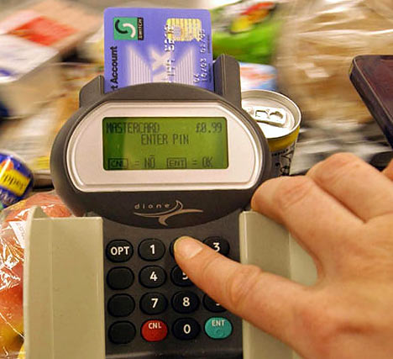PINs (Personal Identification Numbers) are used in a wide   
  range of security applications.
* Four digit PINs (e.g. 1234) are the most common as they are   
  convenient and provide some security. However, six digit PINs   
  (e.g. 123456) should be used whenever possible for improved   
  security.

**Assignment:**

1. Write a simple program that does the following:
   1. Asks the user to enter a 4 digit PIN. This will be the target PIN that the program   
      will try to “crack”.
   2. Runs a loop that starts at 1 and stops when the target PIN is found.
2. Enhance your basic program to include the following code:
   1. The purpose of this code is to measure how long it takes to “crack” the pin.
   2. On average, how long does it take to “crack” a PIN? Try several combinations.

import time

startTime = time.time()

loopCount = 1

while (loopCount <= 1000) :

loopCount = loopCount + 1

endTime = time.time()

print("Elapsed time is:", (endTime - startTime) )

1. Many people use insecure PINs that contain repeated digits such as “1111” or simple sequences such as “1234”.
   1. Enhance your program to try some different digit repeats or digit sequences in order to crack the PIN faster.
   2. Include your enhancements before the main loop.
   3. How does this affect the time needed to “crack” a PIN?

This affects the time needed for the pin because the lop takes time to add on.

The pins and the loops I used. The program

print(" ")

print("This program uses a countdown loop")

print(" ")

startCount = int(input("Enter a number:"))

"""

This loop counts down to zero

"""

currentCount = startCount

while (startCount <= 0) :

print("Count = %d" % currentCount)

currentCount = currentCount - 1

#Countdown Completed!

print("Blastoff!!!!")

count = 1

while (True) :

print("Count is",count)

if (count >= 10) :

break

else :

count = count + 1

import time

startTime = time.time()

loopCount = 1

while (loopCount <= 1000) :

loopCount = loopCount + 1

endTime = time.time()

print("Elapsed time is:", (endTime - startTime) )

1. Research some other ways that people choose insecure PINs. (e.g. birthday dates)
   1. Enhance your program to check for some of these insecure patterns.

There are some ways people use your codes such as the use the 4 last digits of their phone number or their birthday date.

1. Explain how the use of a six-digit pin would increase security. Refer to some of the things you discovered while writing the programs for this assignment.

That would increase security because the amount of time the hacker would take is longer and they would not be able to get it because it would be more difficult. Some things I would do is that I would add the six digits in a hard way so that I would not able to get hacked.